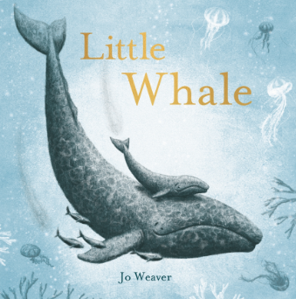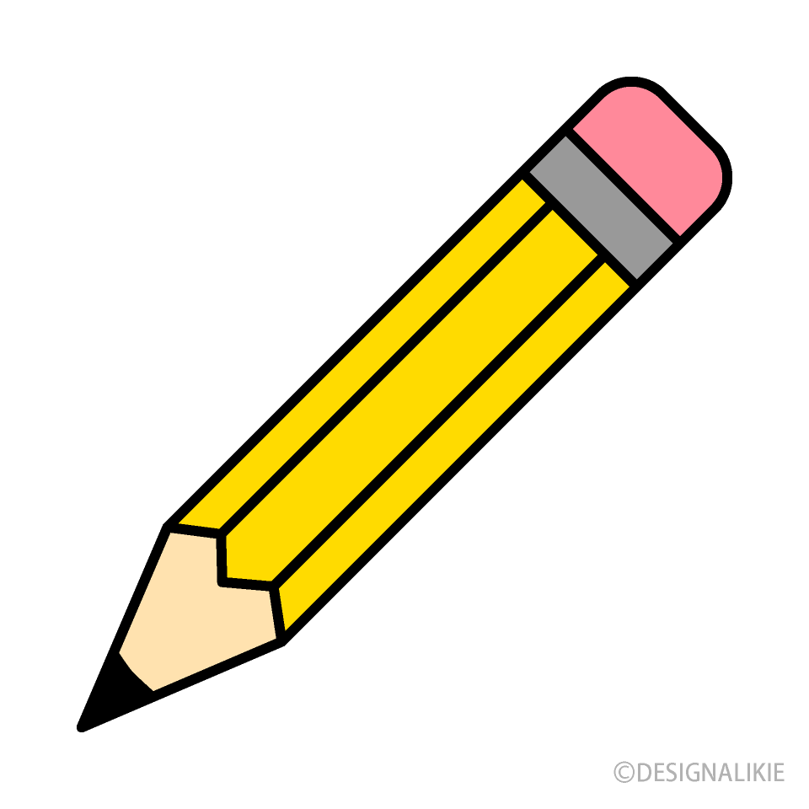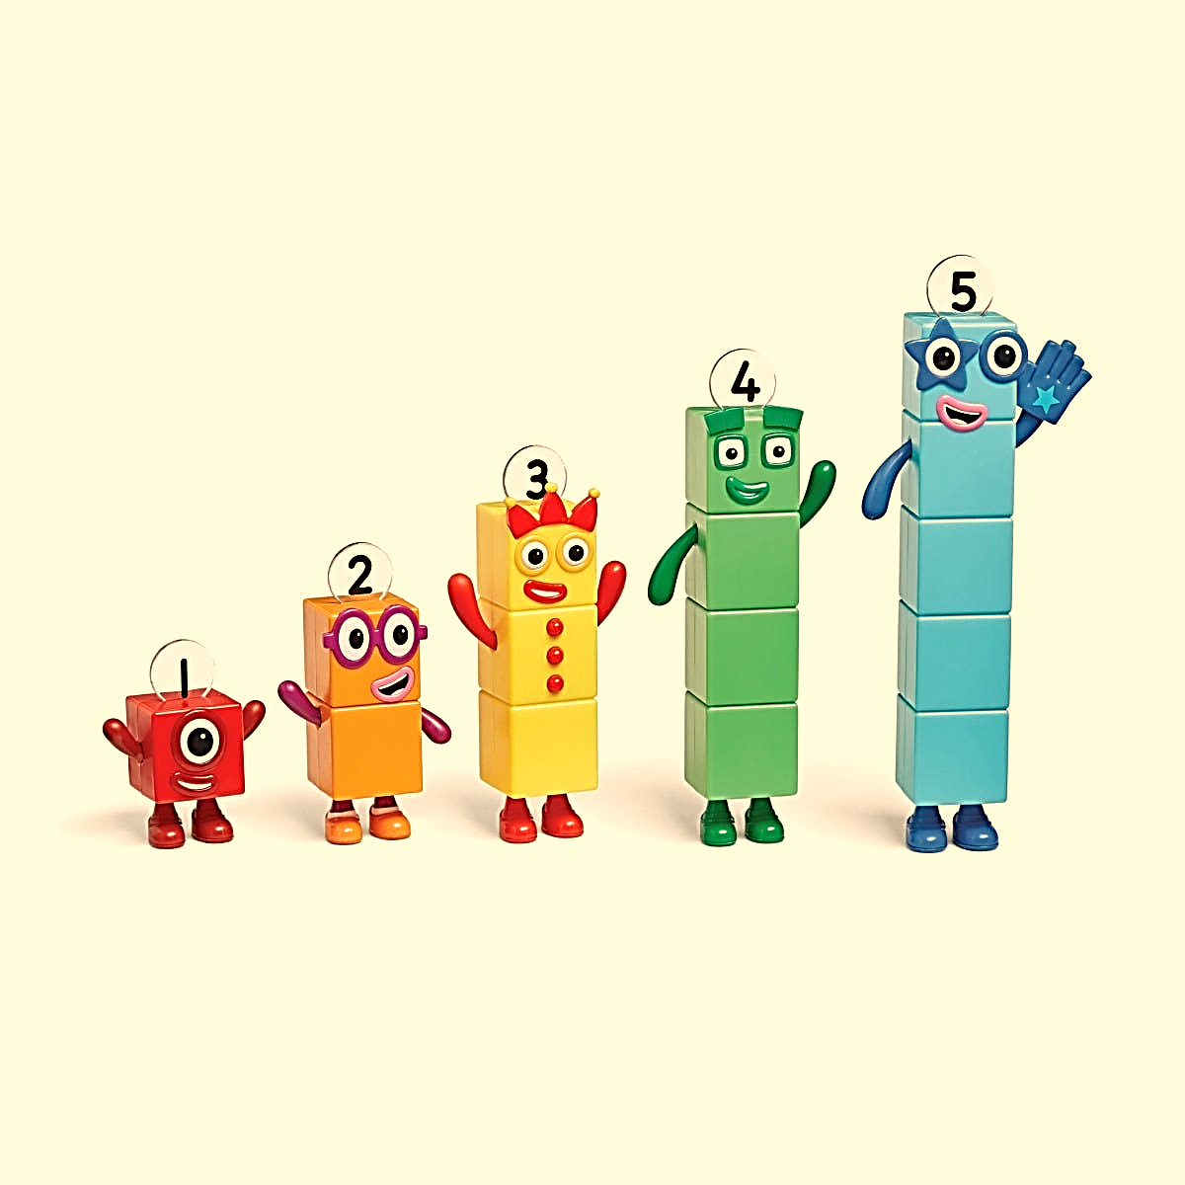

**Literacy-** We will be reading the story ‘Little Whale’ by Jo Weaver. We are aiming for your child to be able to discuss the different parts of the story (beginning, middle and end) and to be able to order the key events. Your child will also be writing short sentences about the story.

Our Enquiry Questions

**Phonics-** We will be teaching two tricky words, two high frequency words and four sounds (including diagraphs) each week. By the end of this term your child should be able to read phase 3 books by decoding and blending the sounds in. Your child should be able to write words and short sentences using the sounds they know. Their phonics homework booklet will support them with this.

**Maths-** We will be exploring numbers 6-10 and supporting the children to develop an understanding of the composition of these numbers. They will be practising their number formation and developing their subitising skills (recognising quantities without counting). The children will also be working out and recalling number bonds for numbers 6-10.

Spring 1 – Curriculum Overview – Under the Sea

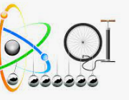

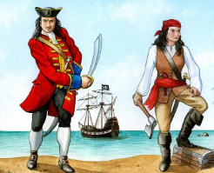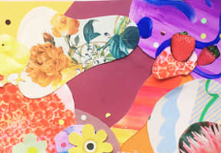

**Art-** What is collage?

**RE-** What isChinese New Year?

**Science-** Can I name different animals?

**Computing-** What makes a good design?

**History-** What can I find out about pirates?



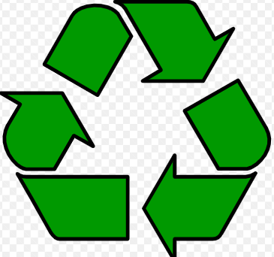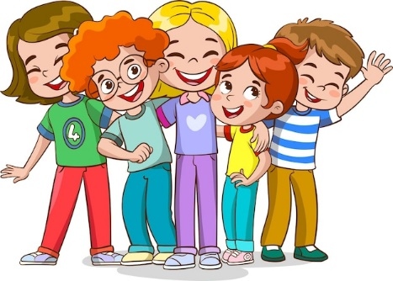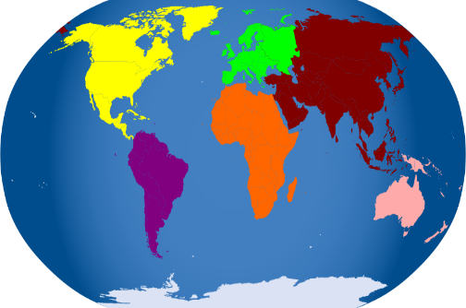

**Music-** What instruments can I hear?

**D&T-** What can I make with recyclable waste?

**PSED-** What is teamwork?

**Geography-** How can I look after my planet?