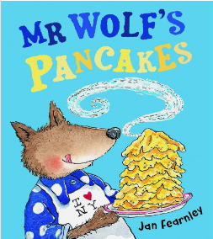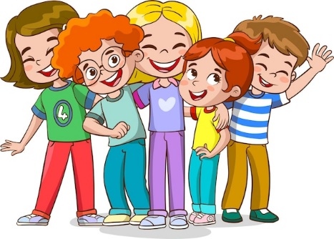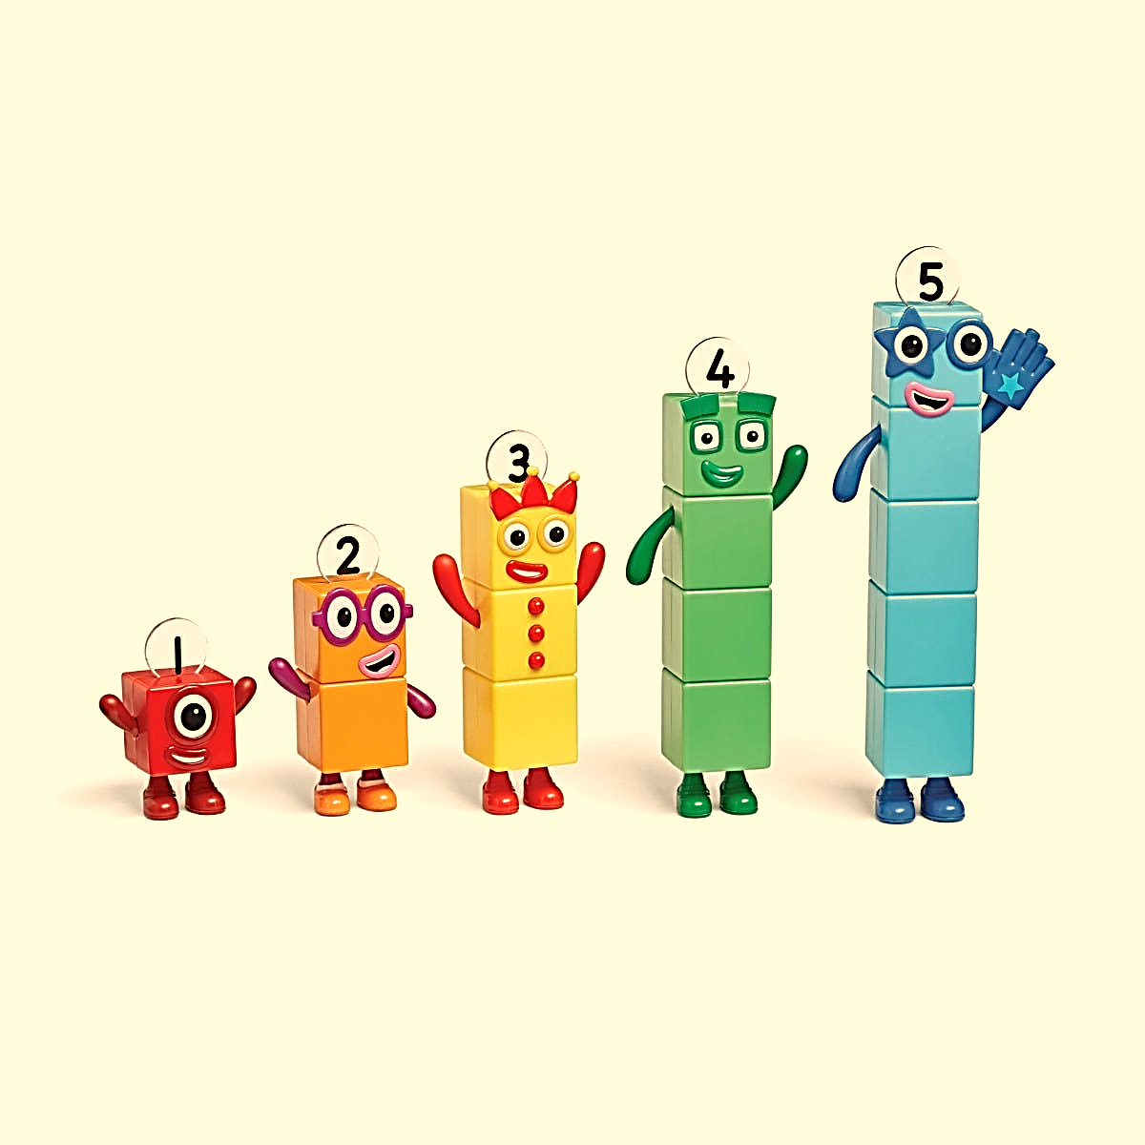

Our Enquiry Questions

**Phonics-** We will be teaching one tricky word, two high frequency words and four sounds each week. By the end of this term your child should be able to read phase 2b books by decoding and blending the sounds in CVC words. Your child should be able to write CVC words and begin writing short sentences using the sounds they know. Their phonics homework booklet will support them with this.

**Maths-** We will be exploring numbers 0-5 and supporting the children to develop an understanding of the composition of these numbers. They will be practising their number formation and developing their subitising skills (recognising quantities without counting). The children will also be working out and recalling number bonds for numbers 0-5.

Autumn 2 – Curriculum Overview – Traditional Tales

**Literacy-** We will be reading the story ‘Mr Wolf’s Pancakes’ by Jan Fearnley. We are aiming for your child to be able to talk about the characters and describe the setting. Your child will be drawing pictures to show their understanding of the story. Your child will also be writing CVC words and short sentences to extend their learning eg: ‘pan’ or ‘put it in’.

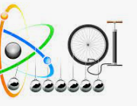

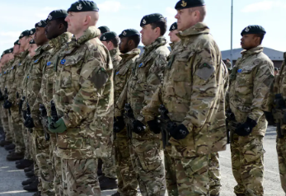

**RE-** What festivals do our friends celebrate?

**Science-** What are forces

**Computing-** How can I stay safe online?

**History-** What did/do soldiers do?

**Art-** What is clay?



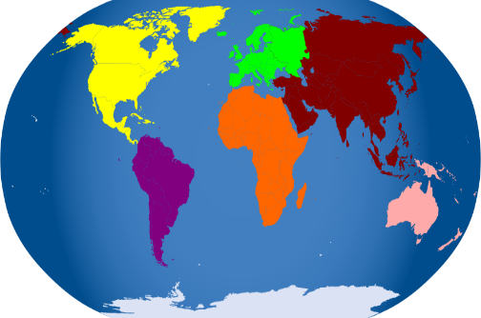

**PSED-** What is bullying?

**D&T-** How are pancakes made?

**Music-** What songs can I perform?

**Geography-** How can I look after my planet?