Helping Hands
Reception - Autumn Term 1 – 2023
In Literacy we will be reading-  Think Big by Sue Hendrick as our Literacy focus but will also be reading the following books:  - Boris Starts School  - A Friend for Henry  - The Boy who loved everyone  - Rosie is my best friend  - Starting School  - Come to School Blue Kangaroo  We will be focusing on rhyme and repetition. We will also be encouraging the children to order key events from the stories that we have read.  We are aiming for all children to be able to recognise and write their name without their name card by the end of this half term!  By the end of this half term your child should be able to write CVC words containing the sounds that they have learnt in phonics (s, a, t, p, i, n, m, d, o, g, l, c, k, ck, e, u, r, h, b, f, ff, ll and ss) | 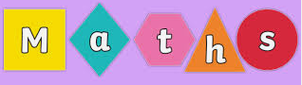  In Maths we are learning and securing our knowledge of numbers 1 to 5.  This will include being able to:  - Recognise patterns of up to 5 objects, without counting.  - Say 1 more and 1 less than numbers up to 5.  - Add and subtracting up to 5.  - Recall the number bonds for the numbers 1 to 5.  - Recognise, write and order the numbers 1 to 5.  - We will also be looking at repeating patterns. We will learn how to copy and create our own patterns. | 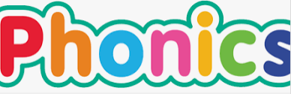  In Phonics we are learning how to sort objects and words by initial sounds and how to orally blend and segment. For example, if we spell the word c-a-t (using letter sounds, not letter names) the children need to be able to tell us what we have spelt ‘cat’.  We will also ask children to orally spell a given word to us (only words with two or three sounds).  Each week we learn 3-4 new sounds and we will send home these new letters as flashcards in your child’s book bag for your child to practise recognising them.  By the end of Autumn 2, we are aiming for your child to be able to read phase 2 books, fluently. Therefore, it is important that they are secure with the sounds we learn each week, so that they can use these to read 2 and 3 letter words.
Art
We like to create Art based on the books that we are reading.

Each week your child will create a piece of art work, based on ‘People Who Help Us.’
Handwriting & Letter Formation  Handwriting is very important for Reception children because they need to strengthen and build control of their fingers and hands.  In order to support this, we do ‘Dough Disco’ each day to strengthen our finger muscles!  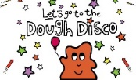  Please encourage your child to hold their pencil correctly at home when practising their writing  (Nip, flip and grip).  Please practise this as often as possible. | PE  Reception children will take part in physical activity with Mr Coleman.  Please encourage your child to be independent when dressing.  Reception have P.E on a Monday and Friday.  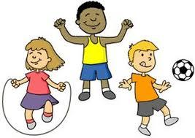 | Understanding the World  This term we will be focusing different occupations around the world and how people help us. The children will be encouraged to talk about their own families and their experiences in life so far.  