Curriculum Overview
Y1 - Spring Term 1 – 2023/4
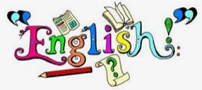  This half term we will read and retell ‘Mole’s Star’ by Britta Teckentrup, developing the children’s empathy for the characters. We will also learn and organise facts about moles, writing our very own non-chronological reports. We are sure you cannot wait to learn all about moles and to hear what happens in this story when the children come home excited about their learning.  Handwriting & Letter Formation  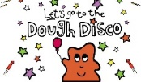  It is very important that children hold their pencil correctly in order to form all their letters. There will be lots of activities to help control and strengthen their finger muscles in our ‘finger gym’ along with daily visits to the ‘dough disco’. | 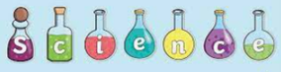  Materials!  In Science, we will be learning about different materials and why they are used for different objects. We will learn their physical properties through comparing, grouping and investigation.  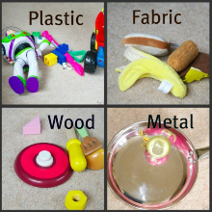 | 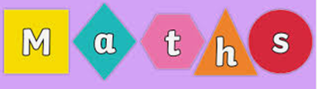  In Maths, the children have worked very hard to learn the place value of numbers to 20. This half term we will be extending their learning with numbers to 50. We will compare these numbers and continue to learn the value of tens and ones.  Using our knowledge of numbers to 50, we will compare numbers as well as order them and find one more and one less.
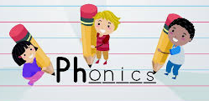  Children will continue their phonics from last term. We will send a new book home each week on a Monday. Check your child’s planner for their sounds to practise! Please support your child by reading at home at least three times a week and recording this. Planners must be brought to school every day in your child’s bookbag. | 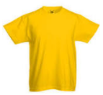  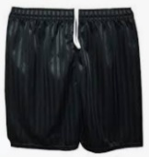  PE  Y1M - Mondays and Wednesdays!  Y1G – Wednesdays and Fridays!  Please ensure your child has their full PE kit in school all week (sometimes P.E lessons can change at short notice). Your child’s P.E bag can live safely on their peg.  All items of P.E kit must be named. | RSHE  We are going to be talking about our feelings and how emotions can affect everyone differently.  We will discuss how to identify what we are feeling and what to do if we are feel emotions which we do not like.  RE  In R.E we will be learning all about Christianity and Islam and we will discuss differences in opinions and behaviours. We will look at what is important to each religion and the important symbols in each religion.
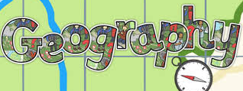  We will continue to explore where live by looking at the city we live in and finding it on a map of the United Kingdom. | DT  We cannot wait to explore mechanisms and make moving pictures. We will evaluate our products against our class criteria for sliders, pivots and levers. We will use our previously taught skills of mixing powder paints to enhance our pieces.  Art  In art we will be looking the collage techniques ripping and cutting. We we use these technqiues to create our very own collage picture of the book ‘Mole’s Star’. | Computing  We will be using the beebots to carry out given commands and we will be making sequences by combining forwards and backwards commands in our plans for a simple programme.  Music  We will be listening to a range of music and identifying different sounds that represent different weather patterns. We will the use our knowledge of pitch, dynamics and tempo to create a piece of music to match a scene with the theme ‘By the Sea’.

